Pull-Out Survey - Proposed Improved Play Area at the Recreation Club – (Re-Issued Due to COVID-19 Collection Postponement)
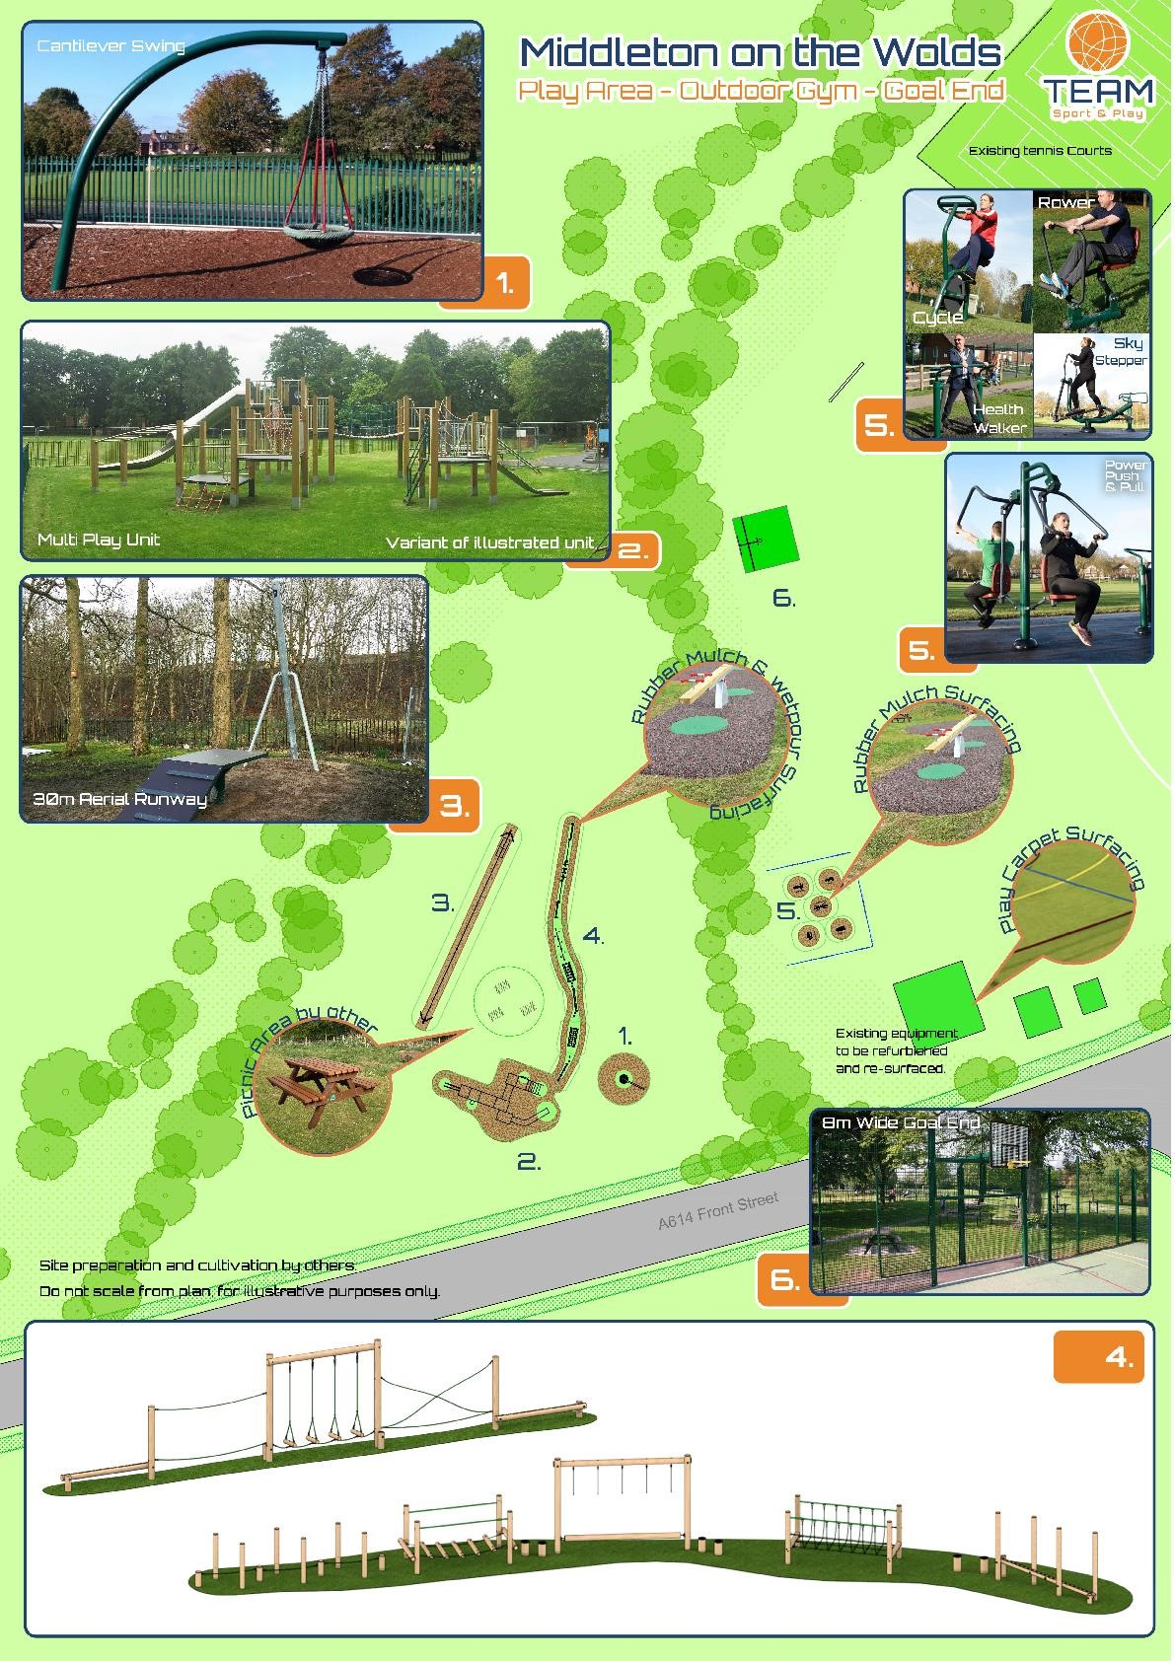

Hi there again! Just a reminder that the Parish Council are looking at the options to improve the play equipment on the Rec Club playing field as part of our obligation to provide play facilities for the over 10s. This includes an option to expand into the next field which the Parish Council are acquiring. We would also like to add an area for outdoor gym equipment, designed for adult use.
We would like to get your feedback on the proposed plans – what you like, what you don’t like as well as anything else you feel you would like to see.
We need as many people as possible to complete the survey below, so please be sure to have your say. Please consult the kids too, as we need to ensure their views are represented in this feedback…

Brief Description of Proposed Play Area
The plan on the front cover shows the draft design. There are 6 main features…
- Basket Swing. This would be a new piece of equipment which allows children to swing in all directions
- Multi Play Unit. This would combine a climbing frame with slides for loads of fun
- Zip Wire. Allows a child to zip down a 30-metre line – a popular item which has been requested at public consultations
- Obstacle Trail – the challenge of getting from one end to the other using balance and fine motor skills
- Adult Gym Area (with the option of being partially screened). 5 or 6 pieces of adult outdoor gym equipment, close to the play equipment so the grown-ups can exercise whilst the children play
- Goal-End. This will be a specially designed area with a goal, basketball hoop and rear fencing so you don’t have to keep fetching your ball back
Note, these are just proposed plans and ideas for which we’d like to get your feedback.
Please base your answers on “normal” times, as we recognise there have been restrictions on playground use due to lockdown and social distancing measures.

We will be collecting these from Middleton On The Wolds (door to door collection) on Saturday 21st November between 10am and 3pm, so please have them ready for when we
knock on your door - or if you wish, please leave the survey secured on your doorstep/front door to avoid face-face contact..

Please complete the survey and remove these pages from the Messenger

Please now turn overleaf to the survey. We will not ask any questions that identify you, but we do need to find out a little that help us put your responses into context…

Survey
Q1. Number of children in your household:
(optional question that helps us put some context around your answers)
Age Range | Number of Children
0-4 years
5-11 years
12 -17 years

Q2. Number of children that would normally visit your household on a regular basis (eg nephews, nieces, grandchildren):
(optional question that helps us put some context around your answers)
Age Range | Number of Children
0-4 years
5-11 years
12-17 years

Q3. How often would these children normally use the Orchard Drive play park (prelockdown)? (tick one)
Often
Sometimes
Occasionally
Never

Q4. How often would these children normally use the Rec Club play equipment (prelockdown)? (tick one)
Often
Sometimes
Occasionally
Never

Q5. How often would these children normally use the goal end at the Rec Club (prelockdown)? (tick one)
Often
Sometimes
Occasionally
Never

Q6. What do you like about the current play equipment at the Rec Club?

Q7. What don’t you like about the current play equipment at the Rec Club?

Q8. What could be improved with the current play equipment at the Rec Club?

The next set of questions is regarding the new plans for the Rec Club play area, so please review the plan on the 1st page and answer these questions…
Q9. Which item do the adults in your household like the most? (Enter numbers 1-6; 1 being the item you like most and 6 being the item you like the least)
Basket Swing
Multi Play Unit
Zip Wire
Obstacle Trail
Adult Gym Area
Goal-End

Q10. Which item do the children in your household like the most? (enter numbers 1-5; 1 being the item they like most and 5 being the item they like the least)
Basket Swing
Multi Play Unit
Zip Wire
Obstacle Trail
Goal-End

Q11. Which would the children in your household use the most? (enter numbers 1-5; 1
being the item they would use most and 5 being the item they would use the least)
Basket Swing
Multi Play Unit
Zip Wire
Obstacle Trail
Goal-End

Q12. If the plans were carried out, how often do you think the children would use the play equipment at the Rec Club when it’s completed? (tick one)
Often
Sometimes
Occasionally
Never

Q13. Would the adults in your household make use of the adult gym equipment? (tick one)
Often
Sometimes
Occasionally
Never

Q14. Would you like the adult gym equipment area to be screened off? (tick one)
No screening
Partial screening
Fully screened

Q15. Please leave any comments below on the proposed plans. Maybe you would have suggestions for other uses for the new area of land, other than for play equipment?

And finally…
Another idea the Parish Council have had, would be to use the new area for a Multi-Use Games Area with all year-round surface. There would be no immediate plans for this to be floodlit, but this could be something that could be looked into in the future.
With this in mind, here are some additional questions…
Q16. Would you make use of the of a Multi-Use Games Area? (tick one)
Often
Sometimes
Occasionally
Never

Q17. What sport would you be likely to play on a Multi-Use Games Area? You may select more than one
Football
Hockey
Athletics
Other (please state below)

Q18. What time of year would you be most likely to use a Multi-Use Games Area? You may select more than one
Winter
Spring
Summer
Autumn

Q19. Given a choice, which would you prefer?
New Play Area
Multi-Use Games Area

Q20. Any other comments regarding the Multi-Use Games Area?

Please remove from the Middleton Messenger Ready For Collection.

We will be knocking on your door to collect on Saturday 21st November 2020 between 10am and 3pm.

If you wish, please leave the survey secured on your doorstep/front door to avoid faceface contact.

Thank you for your participation

